Note the Calculation view must have at least one measure field.

Note: this view MT_CV cannot be seen in SE11

1)Go to Modeler perspective

2)HANA system-Content-package name (pkgTRAINEE04)-ZTR-right click-new-calculation view

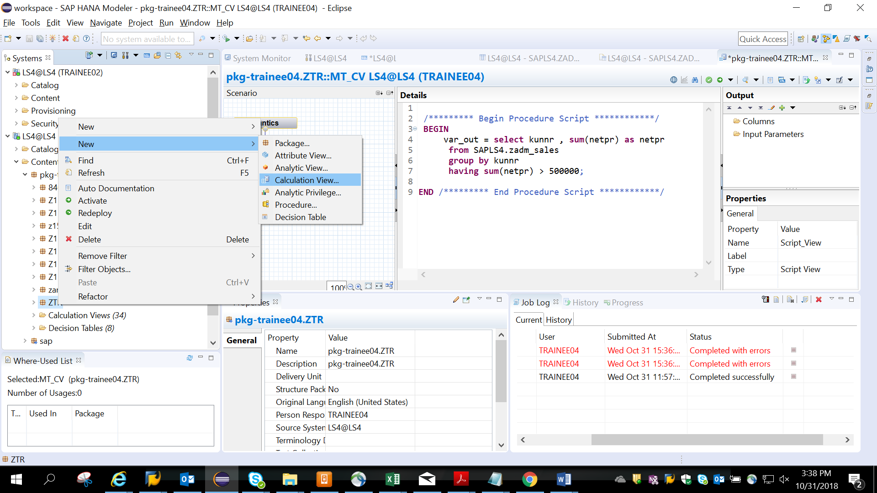

3) Given name to the view name MT_CV - choose SQL script - finish.

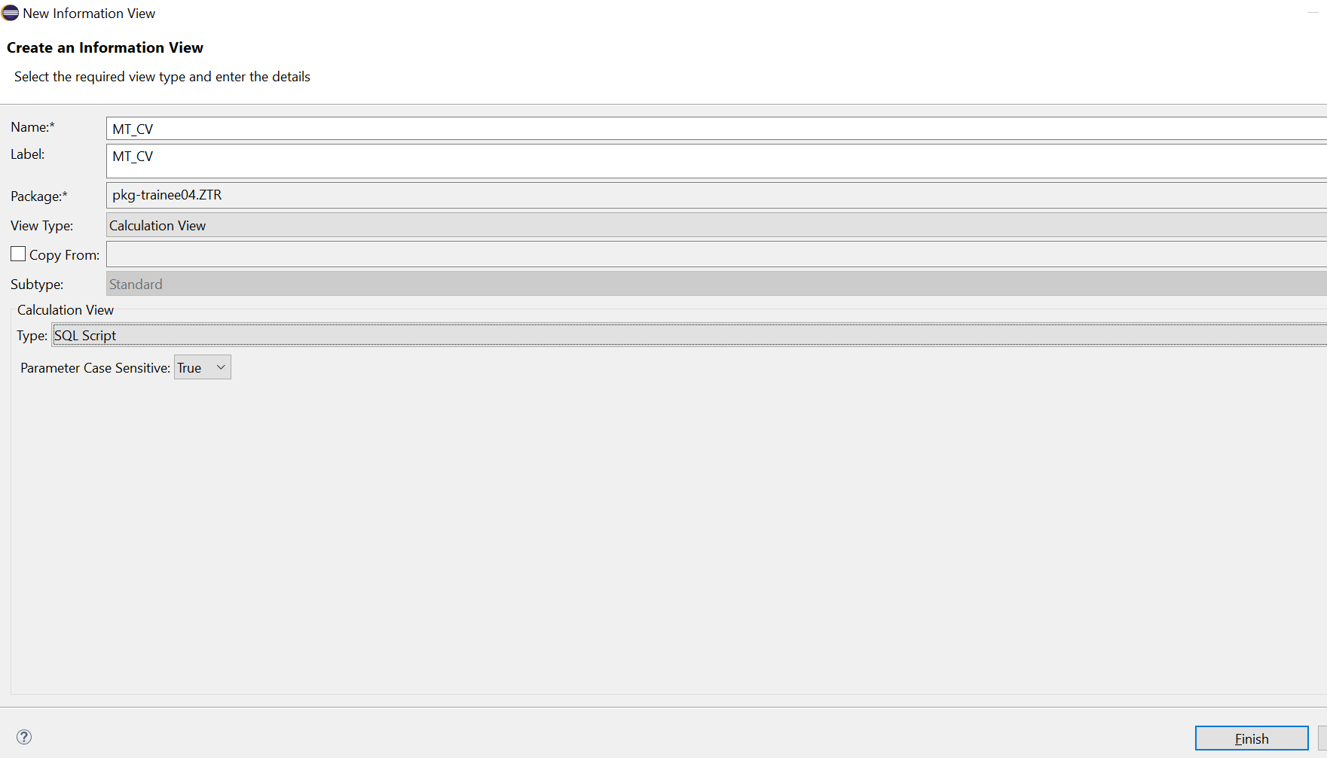

4) Click on the Script view and add the below code

var_out = **select** kunnr, **sum**(netpr) **as** netpr

**from** SAPLS4.zmt_sales

**group** **by** kunnr

**having** **sum**(netpr) > 500000; 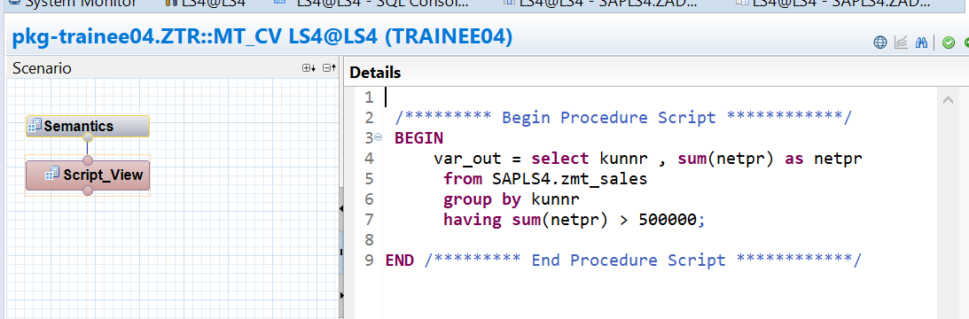

5) To Add the filed names, go to Right corner Output tab - drop down - AddColumnsfrom

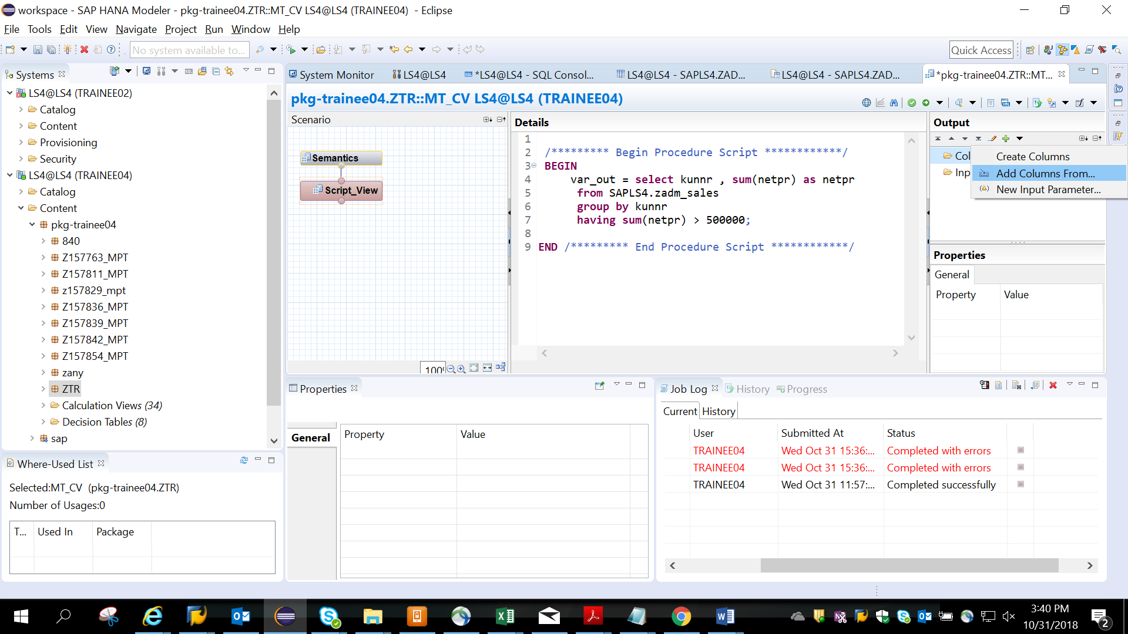

6)Give name of table created in se11

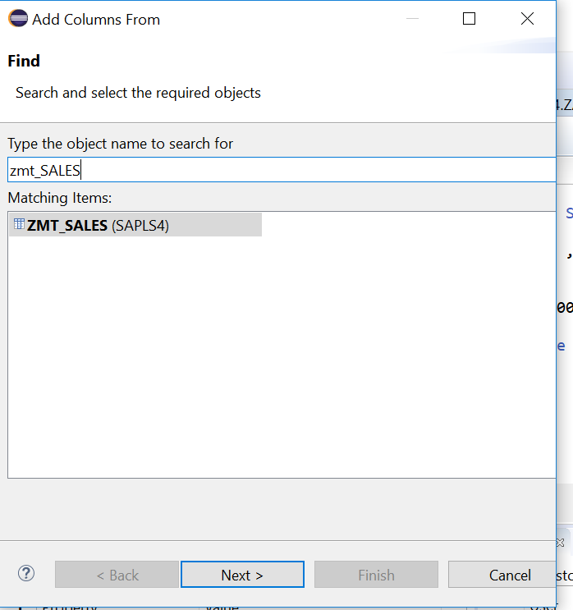

6)Add kunnr and netpr. Finish.

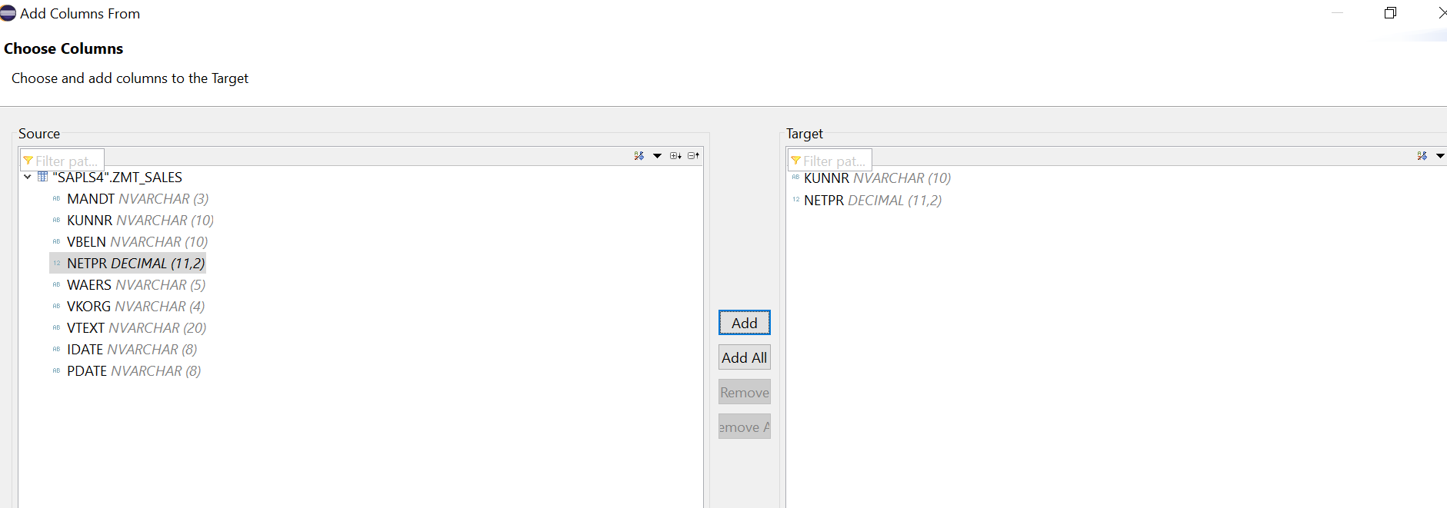KUNNR and NETPR are added

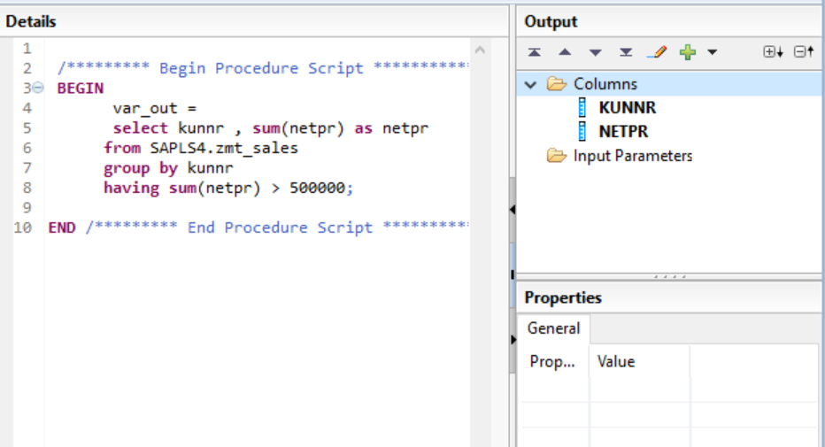

7)Save and activate

8)Confirm view is created by going to the path as shown

Inactive view will have the diamond symbol.

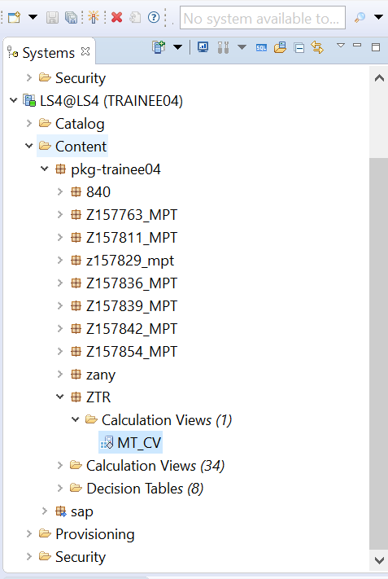

9)Right click on view - activate

Active view will not have the diamond symbol.

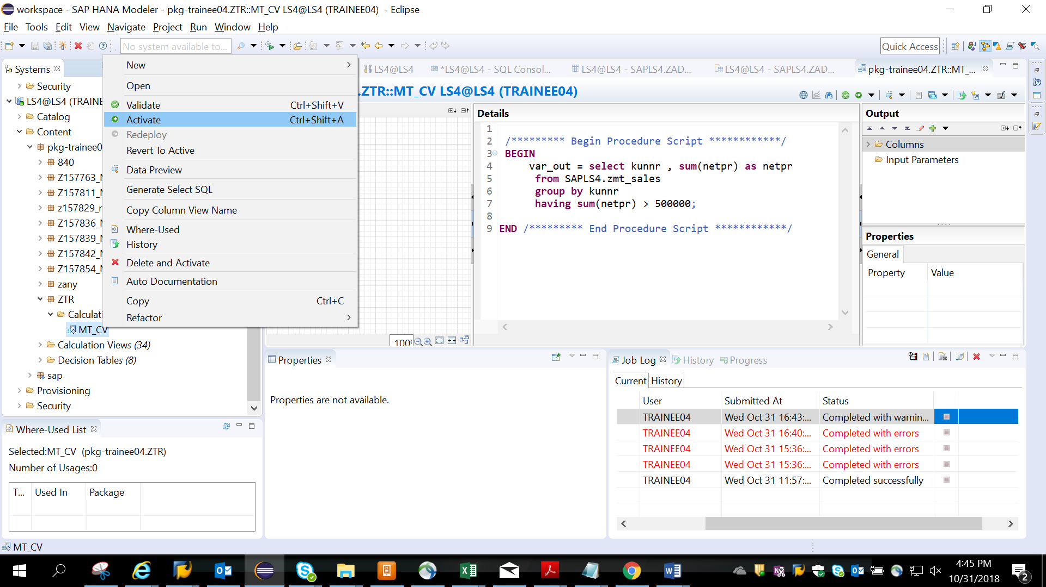

10) right click on view name- Generate select SQL

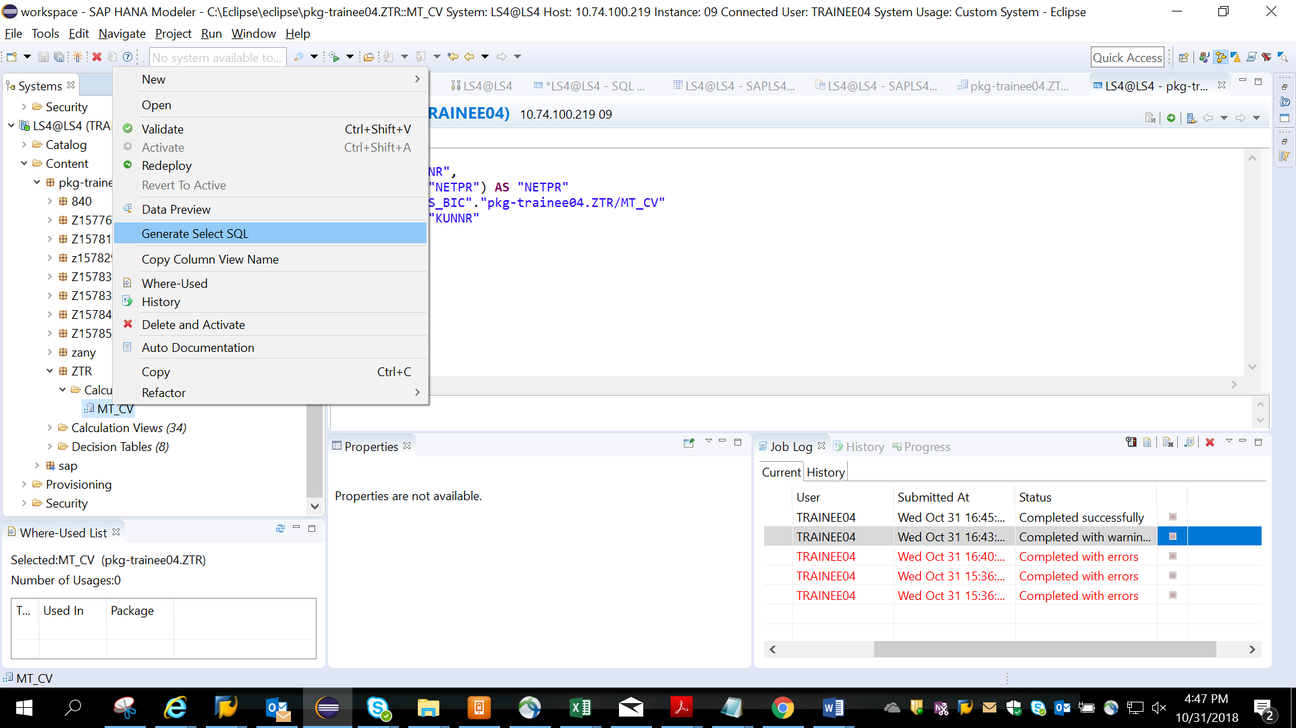

11)You will see the below code generated

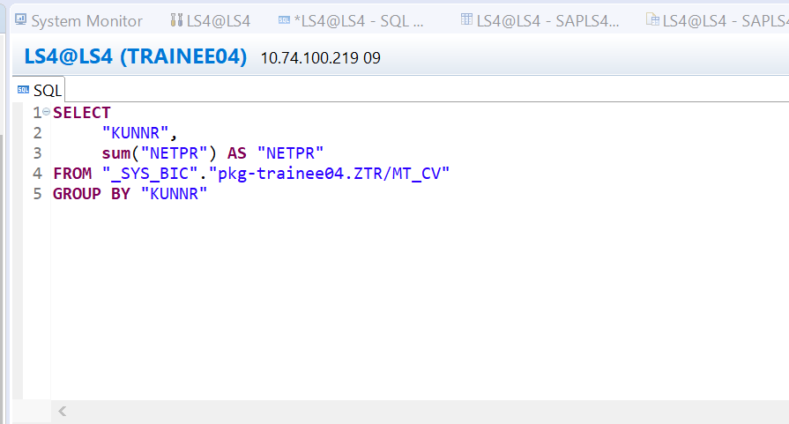

6)You can also check the view in the SYS_BIC schema

